Create a GitHub account. You will need it for the course. Link: <https://github.com/>

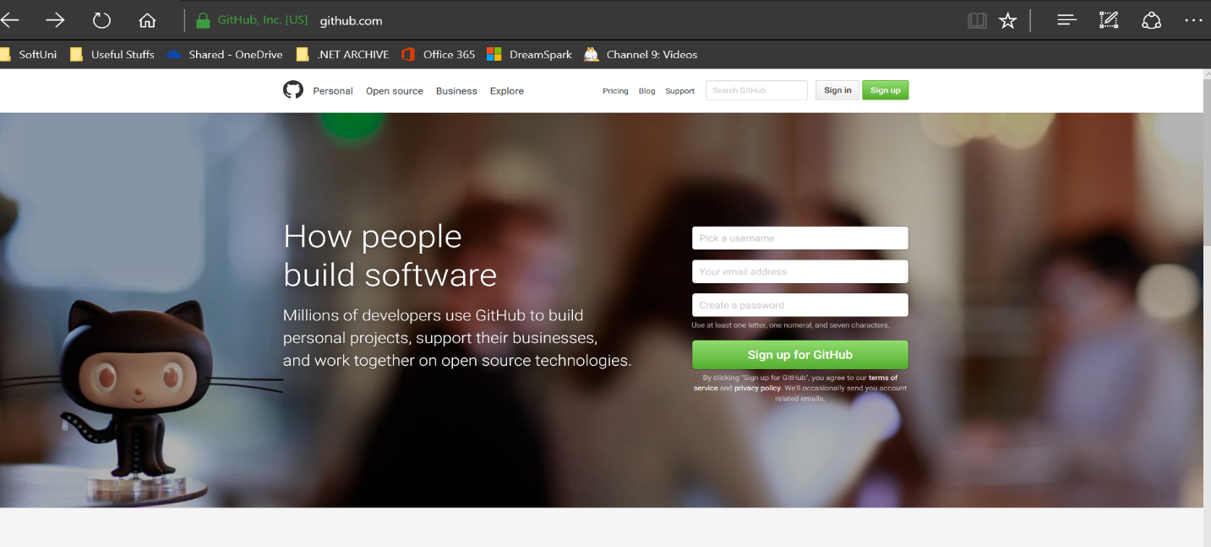

After you verify your account by e-mail you are ready to go. On your profile page search for Repositories.

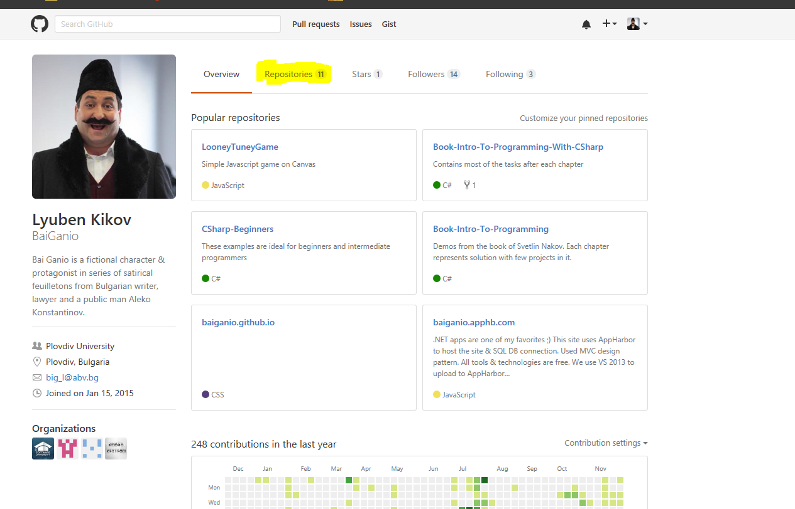

Find the button and create new repo.

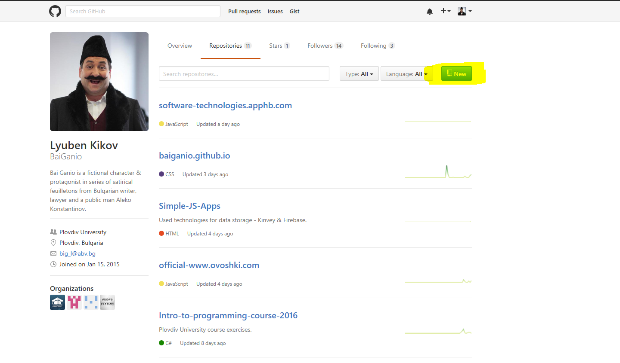

Follow the steps to create your repository.

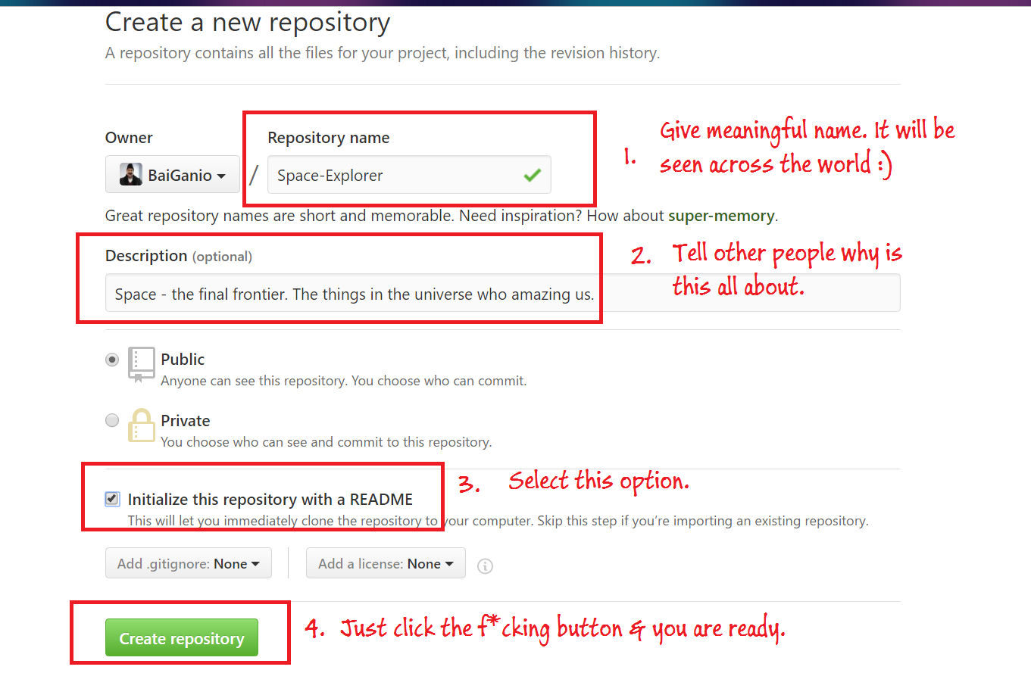

Create new application upon your AppHarbor account.

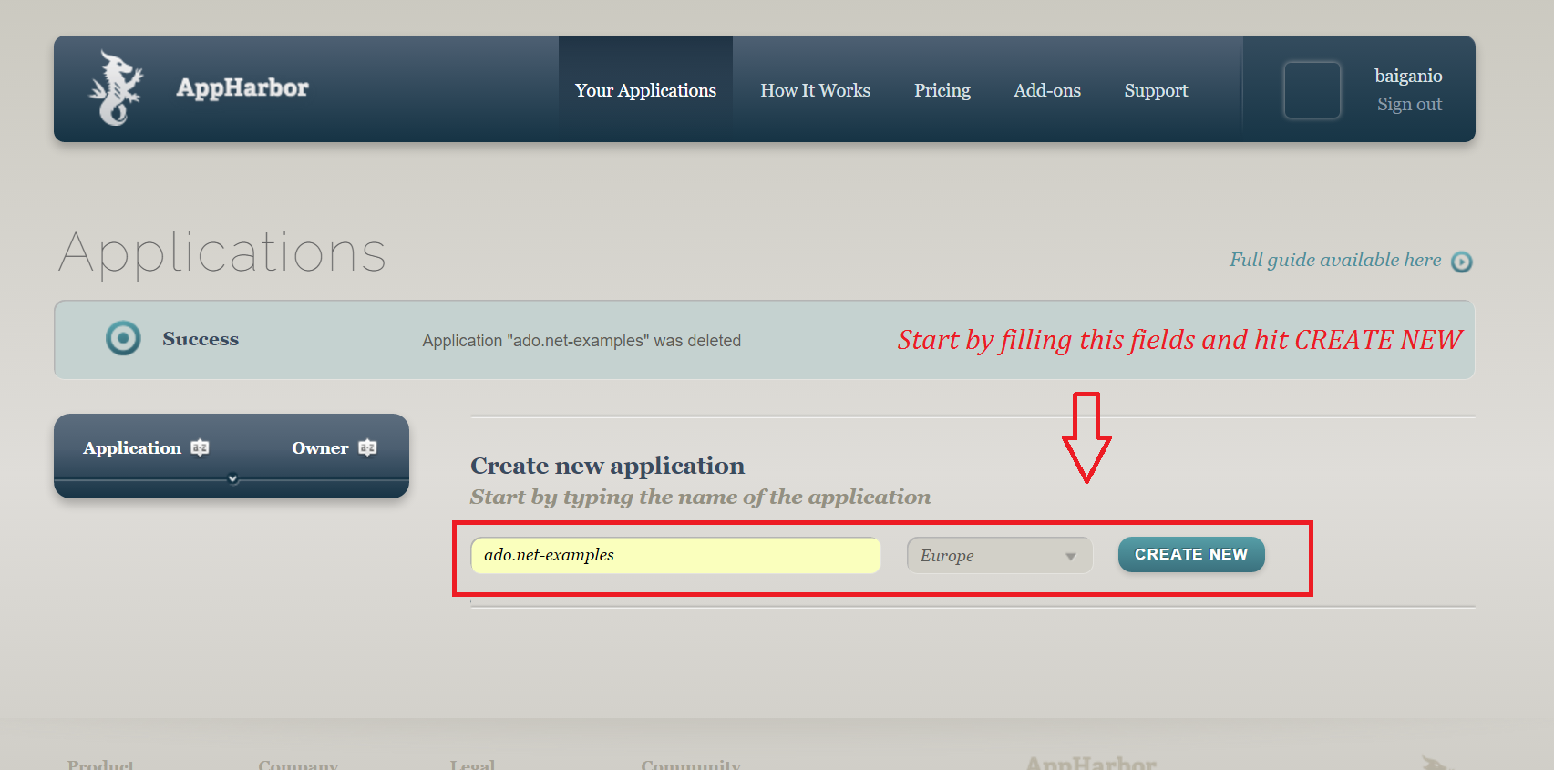

Find the Add-ons or add-on catalog within the project menu. Search below for SQL Server and click the add-on.

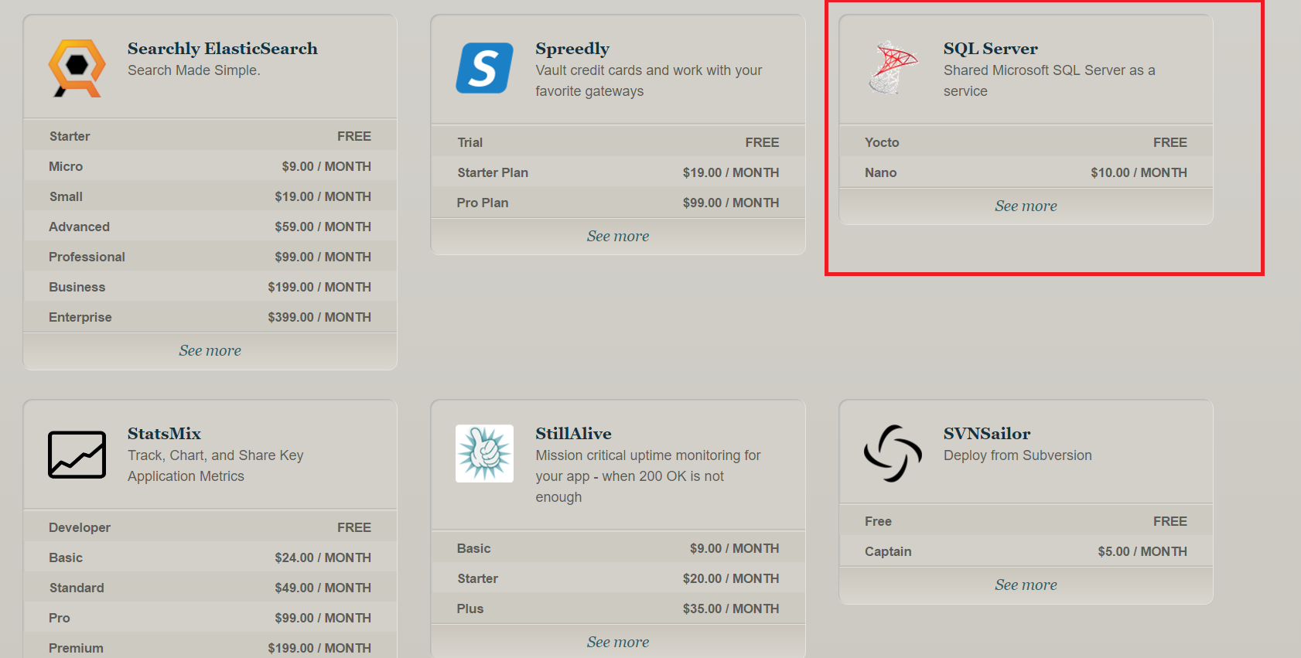

Install Free SQL Server from Yacto.

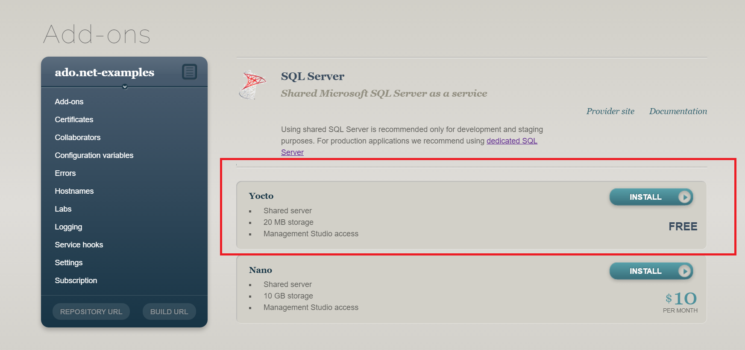

If all is OK we should see this. Configuration variables will needed later. Now we need to configure our repo.

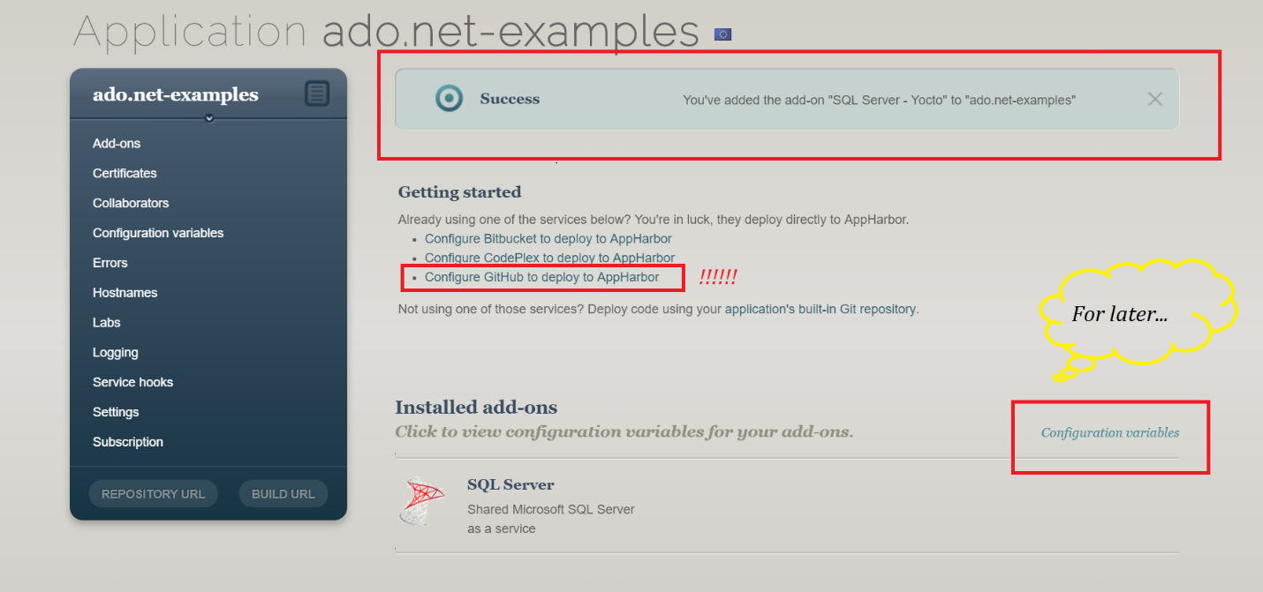

Just do this simple tricks

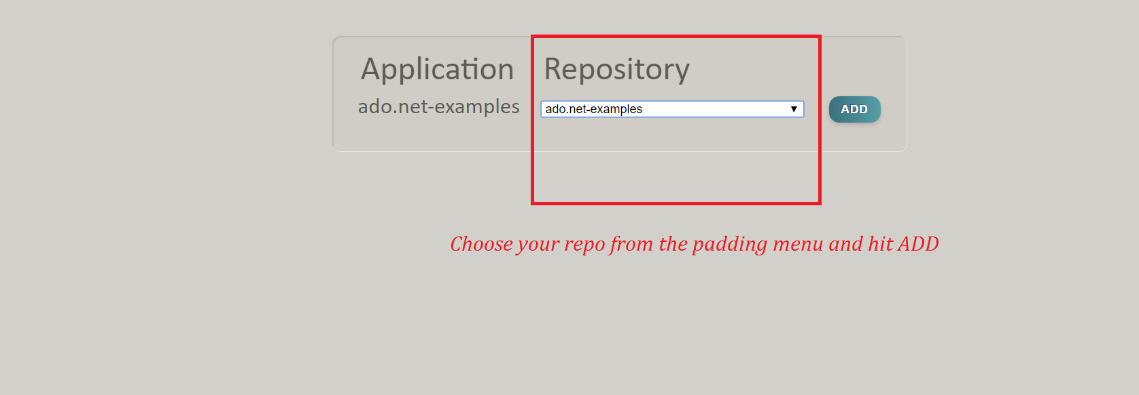

Your setup is done & you can operate upon the app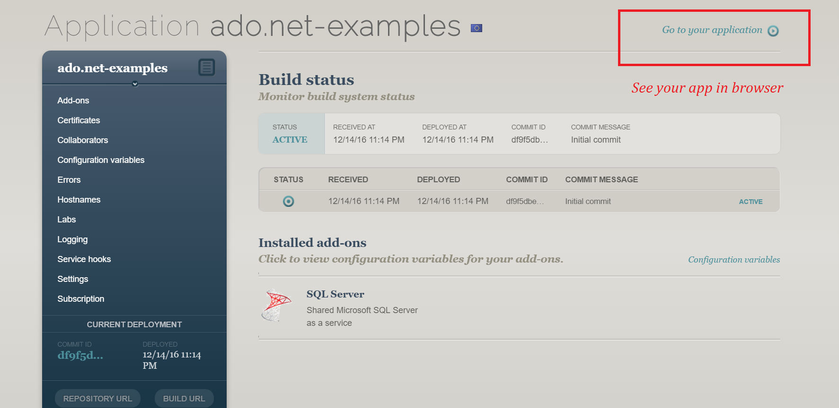

Extract data from configuration variables and paste the in notepad. Connect to the DB with Management Studio.